Learning Early Visual Motion Cues from Pose-Anchored Optical Flow for Human Action Anticipation
Anonymous ICME Submission

Abstract—This paper proposes a simple modification that can be made to existing human skeleton action recognition models to improve action classification accuracy and human action prediction capability. We propose a method of extracting human early visual motion cues by sampling windows of optical flow surrounding skeleton keypoints in image space. We have titled this Pose-guided Optical Flow Feature methodology, PoseOFF. Windows of optical flow sampled surrounding human pose keypoints embed motion information in the learning process and enable the recognition of actions with fewer observed frames. With the addition of a lightweight embedding layer to learn win-dows of optical flow extracted with PoseOFF, three state of the art skeleton-based action recognition models (InfoGCN++, MS-G3D, ST-GCN++) show improvements in action classification accuracy and action prediction ability on three human action recognition datasets. The three models were trained and evaluated on the NTU RGB+D 60, NTU RGB+D 120 skeleton datasets and the UCF-101 RGB dataset. Evaluation of the models on an RGB only dataset demonstrate the broad applications of data extraction and embedding method.
Index Terms—Human Action Recognition, Online Action Recognition, Human Motion Prediction, Multi-modal Media Computing

- Introduction
Human action prediction is a common task in computer vision that aims to predict actions in video data. Where such predictions are required quickly and as part of a human-responsive interaction loop, the problem becomes one of action an-ticipation in which the aim is to of achieving accurately predict actions in as few observed frames as possible. Example applications include human-robot teaming [20], AR/VR applications [CITE], safety monitoring in video surveillance [14], among others. In such cases, rapid low-latency action anticipation may allow interactive systems to pre-load resources such as pre-loading relevant objects in mixed reality (XR) systems, or pruning and/or priming potential response actions in human-machine interfacing contexts, supporting quicker, more natural interactions.
[Short summary of optical flow, what it tells us]
Anticipatory action prediction is well established in the primate brain. In particular, the role of early visual motion cues are well understood to offer predictive and response-priming benefits during human movement and action [CITE]. In human vision, these motion cues are perceived at early stages of visual processing, made available from optical flow – the perceived movement of light patterns projecting onto the eye - to prime other centres of the brain (e.g.,, the pre-motor cortex) [12]. Human vision re-search indicates that the human motor system plays a crucial role when observing and predicting other’s actions [6]. In pri-mate brains, kinematic information of human skeletal interest
points, typically joints, supports human action prediction, as well as emotional intent understanding. This motivates the consideration of how such kinematic information, as well as human early visual motion cues, can be used to support similar capabilities of visual interpretation of human movements in computer vision scenarios.
Human skeleton keypoints are 2D or 3D locations of major body joints extracted from images or videos, providing a compact and interpretable representation of human pose in each frame. However, skeleton keypoints are inherently static descriptors and do not capture the local motion context surrounding each joint. Although tracking keypoints across frames yields displacement vectors, this point-based information omits important second-order motion characteristics—such as instantaneous accelerations, rotations, or subtle surface deformations—that are only evident in the surrounding optical flow field. As a result, skeleton-only representations encode joint positions and coarse movements but miss the richer local dynamics that are critical for early action understanding. For actions with similar gross body movements—such as distinguishing a handshake from a punch—keypoint-only models are unlikely to make accurate predictions until most of the action sequence has unfolded. In contrast, keypoint-anchored visual motion cues (e.g., wrist acceleration, torso rotation or deformation) may provide early discriminative signals that support faster and more reliable action prediction.
.

Dedicated skeleton action recognition datasets often require human actions to be captured from multiple angles using multiple RGB-D sensors to produce reliable skeleton information [16] [8].
There is a lack of research using human skeleton keypoints, and skeleton based methods for the purpose of rapid, low latency action prediction [CITE].
RGB-only approaches to human action recognition must contend with large amounts of calculations needed to process video data. Complex environments, such as outdoor settings or shifting camera perspectives, present challenges for RGB-only models in capturing robust human action features [19]. RGB-only models designed to perform human early action recognition suffer when distinguishing intra-class differences and inter-class similarities.
To address these challenges, we propose a method of embedding localised spatio-temporal features extracted from keypoint-anchored windows of optical flow in existing skeleton-based action recognition models. Our Pose-guided Optical Flow Feature extraction method (PoseOFF) involves the strategic sampling of windows of optical flow surrounding human skeleton keypoints. Optical flow can provide more nuanced information than the simple displacement vectors of skeleton keypoints. A simple embedding layer integrated in three state-of-the-art skeleton-based action recognition algo-rithms shows an improvement in classification accuracy and action prediction.
The main contributions of this work are:

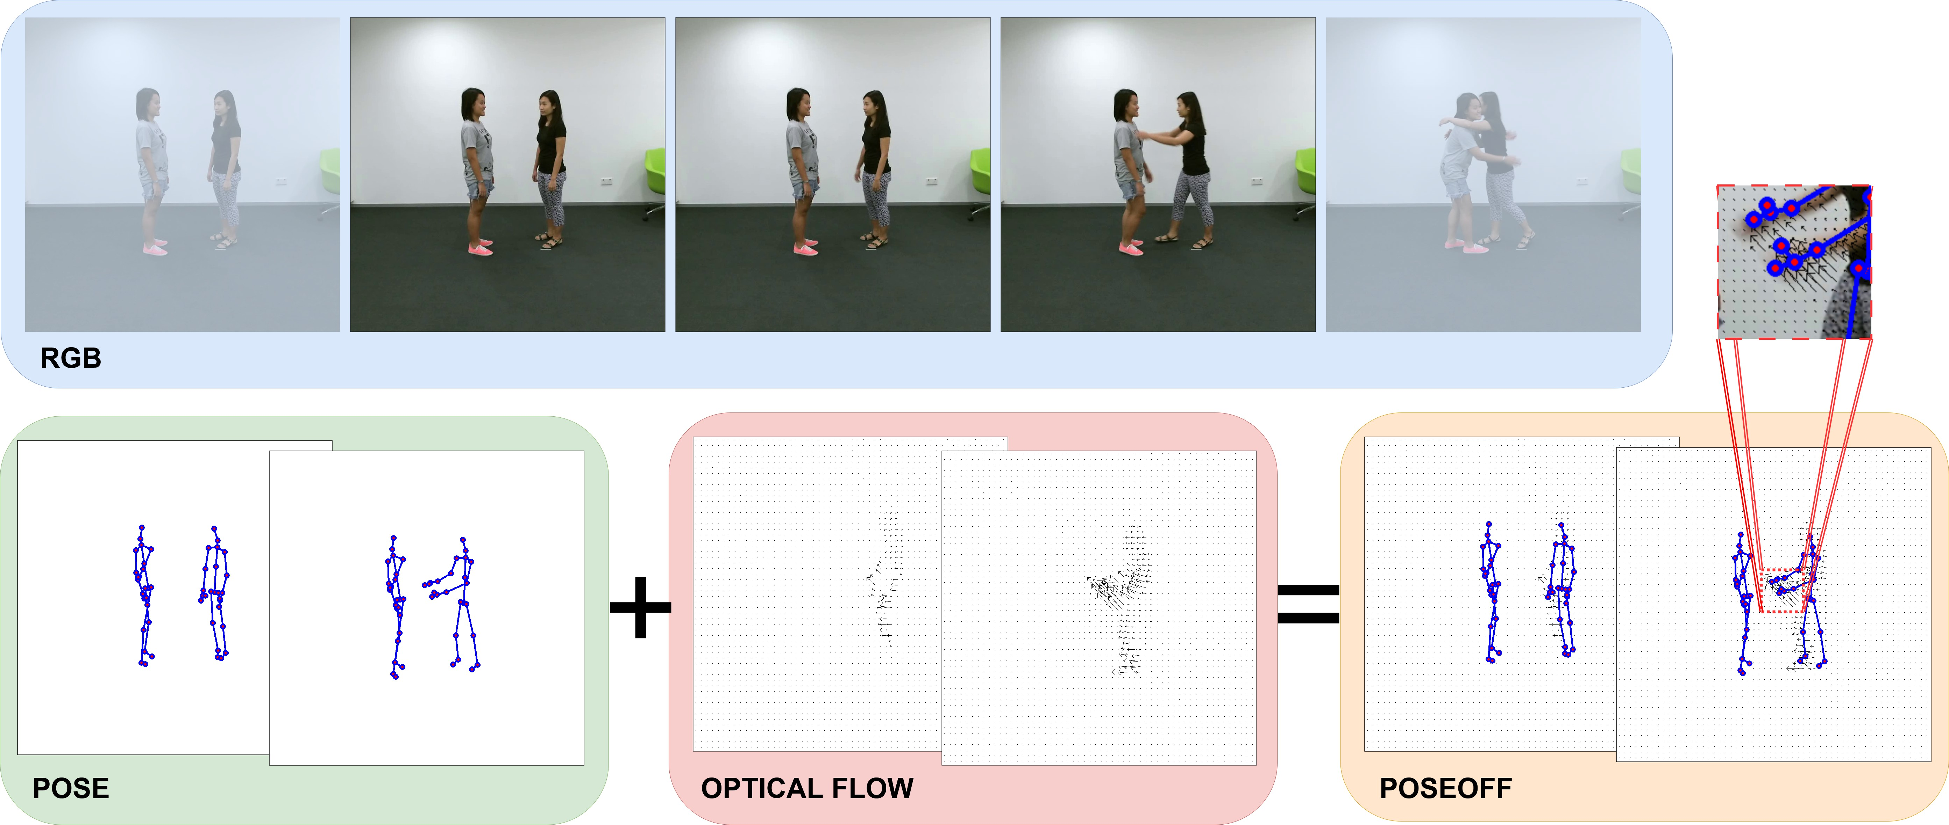

Fig. 1. Extraction method for sampling windows of optical flow surrounding human pose keypoints. From the RGB videos, both human skeleton keypoints (pose) and optical flow are extracted. Windows of optical flow vectors are sampled surrounding each human pose keypoint to generate Pose-guided Optical Flow Feautres (PoseOFF). This PoseOFF data includes both joint coordinates in (x,y,z) space, as well as 25 (u,v) vectors representing the window of optical flow sampled surrounding each pose keypoint.

- PoseOFF, a novel feature embedding derived from optical flow to encode local spatial visual motion cues forearly human action prediction from early visual motion cues.
- A novel embedding layer that can be easily implemented in existing skeleton-based action recognition models to learn windows of optical flow.
- The first demonstration that embedding early visual motion cues at pose-anchored locations can support reduced latency action predictions at comparable accuracy. We show this for three state-of-the-art skeleton-based action recognition models, using three established action prediction datasets. .
- Novel insights guiding the practical implementation of our proposed approach within real-time vision processing pipelines to support responsive and robust action anticipation.

The paper is structured as follows. Section II … Section III, etc

- Related work
Action anticipation is crucial for successful performance in elite sport. In many ball-sports, it is nearly impossible for the human eye to accurately track the trajectory of the ball. A meta-analysis [11] of eye-tracking research in sport-ing contexts indicates that elite athletes direct their gaze to information-dense areas. Football goalkeepers that received perception training on areas of a penalty taker’s body to focus on showed an increase performance when anticipating the direction of the penalty taker’s shot [15]. In social situations, humans fixate primarily on the torso, and self report that their attention focuses on hands, elbows and feet [4].
Skeleton keypoints that are designed to represent human pose keypoints can be depicted as graphs, with graph nodes and edges representing human joints and bones respectively. This compact representation lends itself well to machine learning techniques based in graph theory, such as graph convolutional networks (GCNs) [5].
A GCN proposed by Duan et al. [3], ST-GCN++, achieved competitive performance on skeleton-based action recognition
datasets without the need for complicated attention mecha-nisms to model temporal dynamics. ST-GCN++ provides a baseline for future skeleton-based action recognition models. Liu et al. [9] designed MS-G3D, a skeleton-based action recognition model utilising spatial-temporal graph convolution modules, to pass information across different graph scales. Both ST-GCN++ and MS-G3D perform action recognition using full video sequences, and do not have explicit human action anticipation capabilities.
To approach the problem of human action anticipation using human skeleton keypoints, Chi et al. [2] incorporated a Neural Ordinary Differential Equations module into a skeleton-based action recognition model to model future skeleton states. Their model, InfoGCN++, was able to classify human actions in skeleton datasets with fewer observed frames than existing skeleton-based action recognition models.
Multi-modal approaches to human action recognition area are also commonly applied. Cai et al. [1] proposed a two-stream architecture for hockey action recognition that utilised both optical flow and human poses. The inclusion of an optical flow stream increased hockey action classification accuracy by 10%, demonstrated the complementary features presented in optical flow and human pose.
Using this motion information [CITE] demonstrated that human actions could be anticipated with fewer frames that using standard RGB videos. [CONT]

- METHOD
We propose a novel feature extraction method designed to be easily integrated within existing state of the art skeleton-based action recognition models. The feature extrac-tion methodology, PoseOFF, is designed to sample information about early human visual motion cues.

By embedding these early motion cues as learnable features in skeleton-based action recognition architectures, we aim to show such features can support such state-of-the-art models achieving comparable accuracy with fewer observed frames. Moreover, we seek to achieve higher action anticipation ability with minimal additional computational overheads, thus retaining the feasi-bility of the methods applied in real-time settings on standard computing hardware.
- PoseOFF
Pose-guided Optical Flow Features, PoseOFF, is our proposed feature embedding for anticipatory human action prediction. PoseOFF aims to capture localised spatio-temporal cuesat the onset of human actions, anchored at each skeletal keypoint, which may be observable from the local deformation of optical flow fields around each point. The choice of sampling these areas in videos is well aligned with vision science literature, which has shown that human perception of other human movement is primed by human motion cues in these key areas in order to react and respond in a timely manner. Given our targeted application areas require similar capabilities, it is of interest to explore how visual motion cues maybe utilised in an artificial vision system.
To obtain PoseOFF features for a video containing a human action, two types of data are extracted from videos; human skeleton keypoints (poses) and optical flow. From each frame of video, human poses are estimated, producing a set of points within image space where key joints are located (for example, elbows, shoulders, hips, knees). For each pair of temporally adjacent frames, optical flow is estimated, producing a vector field indicating the motion of the pixels between the adjacent frames.
Based on the estimated locations of skeleton keypoints, square windows are samples from the optical flow vector field. Human skeleton action recognition models represent the skeleton keypoints as a graph, with nodes of the graph containing information about the relative 2D or 3D positions of keypoints. PoseOFF appends the windows of optical flow surrounding these keypoints as additional graph node informa-tion. An overview of the full action prediction pipelineis depicted in Figure 1.
The input to the PoseOFF embedding extraction method is an RGB video of T frames. For each frame t, we extract up to two human skeletons M , consisting of V keypoints. Each skeleton keypoint contains C_{pose} = 3 channels. Depending on the human pose extraction method, these skeleton keypoint channels either represent (x, y, z) coordinates, where the z coordinate is an estimation of the distance that keypoint is from the camera, or (x, y, conf.), where conf. is a value representing the pose estimation model’s detection confidence level.
For each pair of temporally adjacent frames in the RGB video, optical flow is estimated to produce a total of T − 1 optical flow vector fields, with (u, v) vectors at each pixel location representing the motion that pixel took to reach
TABLE I
Approximate data size of different forms of data for video
1920 × 1080 PIXEL RESOLUTION VIDEO CONTAINING TWO BODIES AND
100 frames. We assign 25 pose keypoints per body. For
SIMPLICITY, WE ASSUME ALL VALUES ARE STORED AS FLOAT32 (4
BYTES) PER VALUE.

Data type | Number of Samples | Data size
Pose only | 60,000 | 60kB
PoseOFF | 1,060,000 | 1060kB
Pose with full flow | 1,658,880,000 | 1.66GB

it’s current position in the latter frame. Centred at every skeleton keypoint, (x_i, y_i), we compute and sample N × N windows of optical flow vectors, producing a window of shape (N, N, 2). Optical flow vectors may be sampled at a pre-set dilation, where the dilation factor indicates the stride length in image space between adjacent vectors in the N x N grid. vectors are sampled at regular intervals set by a dilation factor to increase the receptive field. Examples of dilated window sampling are presented in Figure 2.
cdmccarthy
2025-12-11 00:29:18
--------------------------------------------
cite
Each optical flow feature window is flattened to produce C_{flow} = 2N ² channels. These channels are appended to skele-ton keypoint channels to produce a total of C = C_{pose}+C_{flow} = 2N ² + 3 channels for each skeleton keypoint. The output of the PoseOFF embedding is a vector of shape:
(T, M, V, C)
cdmccarthy
2025-12-11 22:56:48
--------------------------------------------
I realise we should also provide a concise definition of what optical flow actually

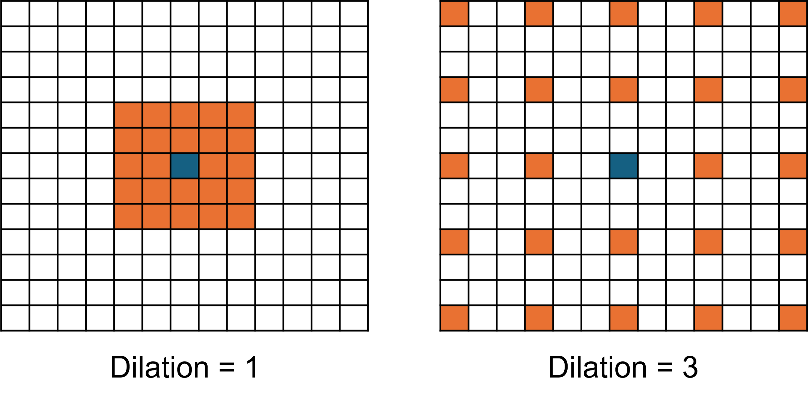
Fig. 2. Example of a 5 × 5 window of flow field sampling with dilation 1 (left) and dilation 3 (right). The grid represents the vector field of optical flow. The blue cell in the centre is the optical flow vector aligning with the pixel coordinates of the human pose keypoint around which the flow window is being sampled.

PoseOFF sampling provides a considerably more data ef-ficient method of embedding optical flow information than training a neural network to learn from the entire flow field.
Table I provides a comparison of data sizes required for pose only, pose with full optical flow, and PoseOFF for a single video containing 100 frames at a resolution of 1920 × 1080 pixels.

O

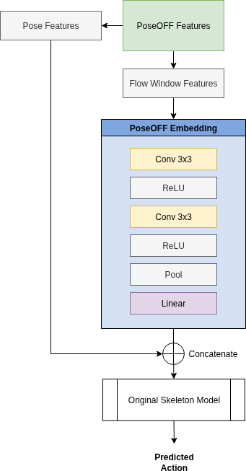

Fig. 3. The embedding layer that learns the windows of optical flow, and concatenates these learned features with the original pose features (x,y,z positions).

- Skeleton-based Action Recognition Models
To demonstrate the applicability and effectiveness of Pose-OFF, we modify three state-of-the-art skeleton-keypoint action recognition models to incorporate learnable early visual mo-tion cues. The embedding layer of each model was modified to include a simple CNN designed to learn the features present in the windows of optical flow. The CNN consisted of two convolutional layers separated by activation layers, pooling and a linear layer. The output of these layers was concatenated with the original skeleton keypoints coordinates as additional channels in the skeleton graph. A diagram of the PoseOFF embedding layer added to each model is presented in Figure 3. The models tested using this methodology were In-foGCN++ [2], MS-G3D [9], and ST-GCN++ [3]. The models
were trained using the hyperparametes defined by the mod-els’ authors, with settings as close to those provided in the respective papers.
The PoseOFF extraction method utilises human skeleton joints as locations in image space from which to extract win-dows of optical flow. For this reason, the results presented in this paper are models trained and evaluated using the skeleton joint stream only. To test each model’s performance for the
task of early action recognition, the final frames of the input sequence were masked at specific ratios (10% increments of the full sequence) to simulate partial observation of the action. We used the temporal padding methods outlined in [2], [9], and [3] to pad the partially observed sequences to the frame length for each model’s input.
- Implementation
All models were implemented in Python using the Py-Torch learning framework [13], using the code provided by their authors. Optical flow was extracted using the PyTorch implementation of the RAFT algorithm [18]. RAFT was selected on the basis of it being …. When skeleton keypoints are not available, we extract human pose keypoints using the YOLO-POSE Large model [10].
The hyperparameters were chosen to match those defined by the model’s authors for the NTU RGB+D 60 and NTU RGB+D 120 datasets. For the UCF-101 dataset, which did not have hyperparameters defined by the authors, we chose to mirror the settings used for the NTU RGB+D 60 dataset where possible. Both the base model and PoseOFF embedded model were trained with identical hyperparameter settings.
- Datasets
The models were trained and evaluated on three different datasets; the NTU RGB+D 60 dataset [16],NTU RGB+D 120 dataset [8] and the UCF-101 dataset [17].
The NTU RGB+D 60 and NTU RGB+D 120 datasets con-sist of images obtained from three separate Microsoft Kinect v2 sensors, with ground truth and contains 3D human skeleton data for every sample. These datasets contain RGB videos, depth sequences, skeleton data (3D locations of 25 major body joints), and infrated frames. Distinct train/test splits (evalua-tions) are provided by the authors in the respective papers for each dataset, ensuring all models that utilise these datasets are training and testing on the same samples to provide fair comparisons. Samples in these datasets are assigned one class label from a possible 60 or 120 classes respectively. Given the ubiquity of these datasets in the skeleton action recognition literature [2] [9] [3], they were chosen to provide a baseline for comparing base model performance to a model trained with PoseOFF embeddings.
The UCF-101 dataset is composed of human actions within unconstrained videos collected “in the wild”. This is an RGB only video dataset, and both the human skeleton keypoints and optical flow were estimated using the methods outlined in Sec. III-C. The authors provide three distinct train/test splits. This dataset was chosen as it provides a challenging skeleton action recognition task, using videos that were collected out-side of laboratory conditions like those present in the NTU RGB+D datasets.
The RGB video data of the NTU RGB+D datasets has a resolution of 1920 × 1080 pixels, whereas the UCF-101 dataset has a resolution of 320 × 240 pixels. Windows of optical flow for the PoseOFF embedding were sampled with a dilation factor of 3 for the NTU RGB+D datasets and a dilation factor of 1 for the UCF-101 datasets. A higher dilation factor

was chosen for the NTU RGB+D datasets given their higher video resolution. See Figure 2 an example of dilated window sampling.

- Experiments
Evaluation Metrics. For the task of action classification, model performance was measured using the classification accuracy; that is, the percentage of samples that the models were able predict the correct class label of after observing the full action sequence. For the task of action prediction, both the classification accuracy at each given observation ratio and the Area Under the Curve (AUC) are reported. The AUC is a measure of the model’s performance across all evaluated observation ratios, and is calculated as:
L Acc
These experiments were designed to test whether PoseOFF effectively extracts human early visual motion cue informa-tion. Additionally, we were seeking to understand the role of human early visual motion cues in providing standard human skeleton action recognition models the ability to anticipate human actions.
The action prediction results are an indication that the embedding of the features extracted with the PoseOFF method are able to anticipate the action happening in the videos more accurately, and with fewer frames. The gray dotted lines in these graphs is used to indicate the highest performance of the base model, in order to compare it’s performance with the PoseOFF embedded versions of the models.
The action prediction results on the NTU RGB+D 60 dataset, shown in Figure Figure 4, show that all models are able to predict the action taking place with fewer frames. For

AUC =

Nobs
obs
the ST-GCN++ and MS-G3D models, the PoseOFF embedded version of the model only needs to observe 80% of the

where Acc_{obs} is the accuracy at a given observation ratio, obs, and N_{obs} is the number of evaluated observation ratios.
- Action Classification
To test the models’ ability to perform action classification, all models - both the base model and a version of the model with the additional PoseOFF embedding layer, shown in Figure 3 - were trained and tested on full sequences. In the full sequence evaluation, no temporal masking was applied to the input sequence. This test simulates an offline action recognition scenario.
The action classification results are presented in Table Ta-ble II. In this table, we have highlighted the best performing model for each dataset and evaluation. The models trained with the additional PoseOFF embeddings produce a higher classification accuracy across all models and all datasets. The classification accuracy results for the UCF-101 dataset shows the most varied results between the models. This dataset is RGB only, containing human actions from videos “in the wild”. No depth data or skeleton poses accompany the dataset. The poses extracted using YOLO-POSE Large[10] are gener-ally less accurate or precise than those included in the NTU RGB+D datasets. The models trained on data obtained using PoseOFF showed considerable improvements in classification accuracy across all datasets tested.
The RGB only dataset is a good test for the application of PoseOFF features in real world applications. CONT
- Action Prediction
To test the effectiveness of the learnable features present in PoseOFF data, we evaluated each model at different observa-tion ratios of the input sequence. The models evaluated were trained on 100% observation ratio and were evaluated at 10% observation ratio intervals. The InfoGCN++ model produces a action class prediction for every frame of the input sequence (64 frame input), so the observation ratio interval evaluations were not necessary for this model. These results are presented in Figure 4 and Figure 5.
entire action sequence to achieve the same performance as the base model at 100% observation ratio. At lower observation ratios, the ST-GCN++ base model is able to predict the action more accurately than the PoseOFF embedded model. For InfoGCN++, which was specifically designed for the task of action prediction, the PoseOFF embedded version of the model needs to only see approximately half of the input sequence to achieve the same performance as the base model at 100% observation ratio.
The action prediction results on the UCF-101 dataset, shown in Figure Figure 5, highlights the fact that PoseOFF embed-ded models are much stronger at the task of human action prediction.
These results demonstrate that out method is able to increase the overall performance of models on noisy, and more realistic datasets.
The modifications made to the skeleton action recognition models were only in the first layers of the model, and did not significantly alter inner workings of the models. These results demonstrate the effectiveness of data extracted using the PoseOFF method. We believe that the data produced from the PoseOFF extraction method can be easily implemented in any skeleton-based action recognition model to improve the model’s action recognition and prediction ability.
Existing skeleton-based action recognition models can be easily modified in order to learn features extracted with PoseOFF. This can improve the model performance for both human action classification and action prediction.
- Conclusion
We have demonstrated that the embedding of human early visual motion cues into established skeleton based human action recognition can improve the action classification and action prediction accuracy. We have also shown that .....
The implementation of PoseOFF into existing skeleton-based action recognition models requires only a minor modi-fication to the model’s embedding layer. PoseOFF presents a considerably more data efficient method of embedding this

TABLE II
Classification accuracy for all models trained and tested on the NTU-RGB+D (NTU), NTU-RGB+D120 (NTU120) and UCF-101 datasets - joint stream only. The train/test splits (evaluations) for each dataset are presented in separate columns under each datasets heading.

 |  | NTU |  | NTU120 |  | UCF-101
 |  | CS | CV | CSub | CSet | 1 | 2 | 3
InfoGCN++ | Base | 83.52%  88.89% | 91.38%  93.68% | 75.92%  82.70% | 77.61%  83.70% | 59.21%  62.81% | 57.82%  62.54% | 58.90%  62.84%
 | PoseOFF
MS-G3D | Base | 87.40%  89.95% | 93.43%  94.12% | 76.24%  83.22% | 78.75%  85.49% | 61.39%  68.84% | 62.02%  69.88% | 63.45%  66.36%
 | PoseOFF
ST-GCN++ | Base | 84.78%  88.88% | 90.85%  93.70% | 76.54%  82.36% | 76.40%  85.00% | 47.37%  58.27% | 47.96%  60.13% | 46.86%  58.61%
 | PoseOFF
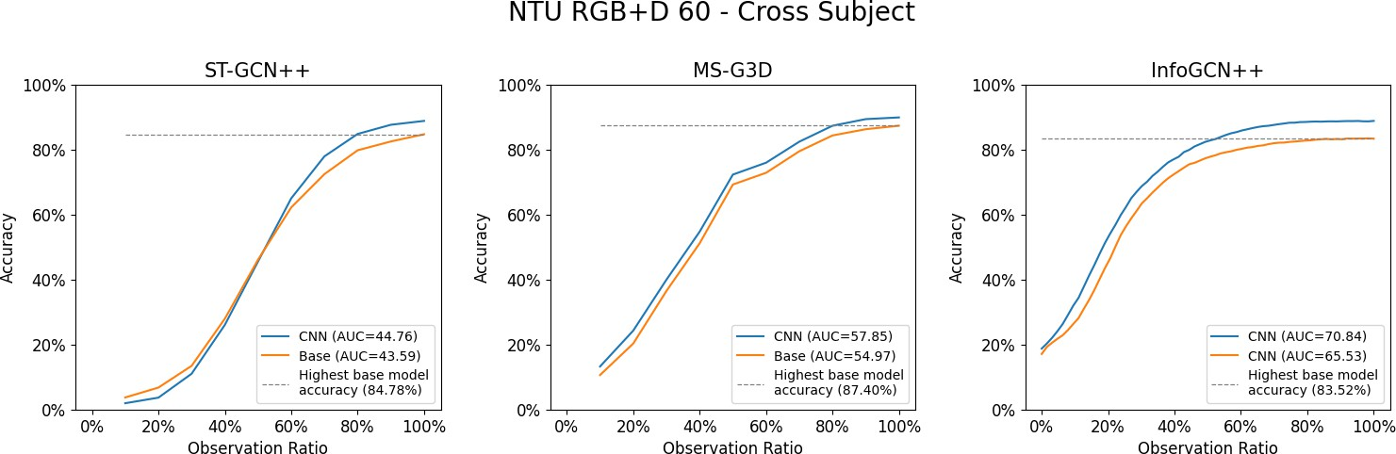

Fig. 4. Models trained using 100% observation ratios, evaluated at 10% observation ratio intervals on the NTU RGB+D 60 dataset, Cross Subject evaluation. The Area Under the Curve (AUC) is reported for each model in the sub figure labels.
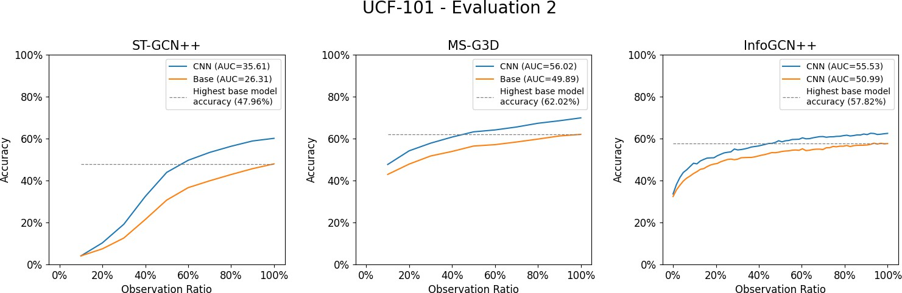

Fig. 5. Models trained using 100% observation ratios, evaluated at 10% observation ratio intervals on the UCF-101 evaluation 2. The Area Under the Curve (AUC) is reported for each model in the sub figure labels.

nuanced human early visual motion cue information into existing models.
In this work, PoseOFF was extracted with a fixed optical flow window sampling dilation. For the NTU-RGB+D and NTU-RGB+D 120 datasets, this flow sampling dilation was fixed to 3 pixels (d = 3), and for the UCF-101 dataset, there was no dilation (d = 1). In future work, we will explore the effects of a dynamic sampling dilation. This dilation factor could vary with quantities such as the apparent size of the human skeleton with respect to the frame size, or a skeleton keypoint’s distance from the camera.
References
- Zixi Cai et al. “Temporal Hockey Action Recognition via Pose and Optical Flows”. In: Proceedings of the IEEE/CVF Conference on Computer Vision and Pattern Recognition Workshops. 2019. URL: https://openaccess. thecvf . com / contentCVPRW2019 / html / CVSports / CaiTemporalHockeyActionRecognitionviaPose andOpticalFlowsCVPRW2019paper.html (visited on 10/25/2024).
- Seunggeun Chi et al. InfoGCN++: Learning Repre-sentation by Predicting the Future for Online Human Skeleton-based Action Recognition. Oct. 16, 2023. DOI:

 | 10.48550/arXiv.2310.10547. arXiv: 2310.10547 [cs]. |  | (Mar. 2023), p. 108164. ISSN: 00426989. DOI: 10 .
 | URL: http : / / arxiv . org / abs / 2310 . 10547 (visited on |  | 1016/j.visres.2022.108164. URL: https://linkinghub.
 | 11/29/2024). Pre-published. |  | elsevier.com/retrieve/pii/S0042698922001705 (visited
[3] | Haodong Duan et al. PYSKL: Towards Good Practices |  | on 03/07/2024).
 | for Skeleton Action Recognition. May 19, 2022. DOI: | [13] | Adam Paszke et al. “PyTorch: An Imperative Style,
 | 10.48550/arXiv.2205.09443. arXiv: 2205.09443 [cs]. |  | High-Performance Deep Learning Library”. In: ().
 | URL: http : / / arxiv . org / abs / 2205 . 09443 (visited on | [14] | M. S. Ryoo. “Human Activity Prediction: Early Recog-
 | 10/16/2025). Pre-published. |  | nition of Ongoing Activities from Streaming Videos”.
[4] | Cathy Ennis, Ludovic Hoyet, and Carol O’Sullivan. |  | In: 2011 International Conference on Computer Vision.
 | “Eye-Tracktive: Measuring Attention to Body Parts |  | 2011 International Conference on Computer Vision.
 | When Judging Human Motions”. In: C. O (). |  | Nov. 2011, pp. 1036–1043. DOI: 10.1109/ICCV.2011.
[5] | M. Gori, G. Monfardini, and F. Scarselli. “A New |  | 6126349. URL: https : / / ieeexplore . ieee . org / abstract /
 | Model for Learning in Graph Domains”. In: Proceed- |  | document/6126349 (visited on 02/14/2025).
 | ings. 2005 IEEE International Joint Conference on | [15] | Geert Savelsbergh, Peter Gastel, and Paulien Van Kam-
 | Neural Networks, 2005. Proceedings. 2005 IEEE Inter- |  | pen. “Anticipation of Penalty Kicking Direction Can
 | national Joint Conference on Neural Networks, 2005. |  | Be Improved by Directing Attention through Perceptual
 | Vol. 2. July 2005, 729–734 vol. 2. DOI: 10 . 1109 / |  | Learning”. In: Int J Sport Psychol 41 (Jan. 1, 2010).
 | IJCNN . 2005 . 1555942. URL: https : / / ieeexplore . ieee . | [16] | Amir Shahroudy et al. “NTU RGB+D: A Large Scale
 | org/document/1555942 (visited on 03/16/2025). |  | Dataset for 3D Human Activity Analysis”. In: 2016
[6] | Gustaf Gredeba¨ck and Terje Falck-Ytter. “Eye Move- |  | IEEE Conference on Computer Vision and Pattern
 | ments During Action Observation”. In: Perspec- |  | Recognition (CVPR). 2016 IEEE Conference on Com-
 | tives on Psychological Science 10.5 (Sept. 1, 2015), |  | puter Vision and Pattern Recognition (CVPR). Las
 | pp. 591–598. ISSN: 1745-6916. DOI: 10 . 1177 / |  | Vegas, NV, USA: IEEE, June 2016, pp. 1010–1019.
 | 1745691615589103. URL: https : / / doi . org / 10 . 1177 / |  | ISBN: 978-1-4673-8851-1. DOI: 10.1109/CVPR.2016.
 | 1745691615589103 (visited on 09/08/2025). |  | 115. URL: http://ieeexplore.ieee.org/document/7780484/
[7] | Bolin Lai et al. Human Action Anticipation: A Survey. |  | (visited on 01/24/2025).
 | Oct. 17, 2024. DOI: 10.48550/arXiv.2410.14045. arXiv: | [17] | Khurram Soomro, Amir Roshan Zamir, and Mubarak
 | 2410 . 14045 [cs]. URL: http : / / arxiv. org / abs / 2410 . |  | Shah. “UCF101: A Dataset of 101 Human Actions
 | 14045 (visited on 12/30/2024). Pre-published. |  | Classes from Videos in the Wild”. 2012. arXiv: 1212.
[8] | Jun Liu et al. “NTU RGB+D 120: A Large-Scale |  | 0402.
 | Benchmark for 3D Human Activity Understanding”. In: | [18] | Zachary Teed and Jia Deng. RAFT: Recurrent All-Pairs
 | IEEE Transactions on Pattern Analysis and Machine |  | Field Transforms for Optical Flow. Aug. 25, 2020. DOI:
 | Intelligence 42.10 (Oct. 1, 2020), pp. 2684–2701. ISSN: |  | 10.48550/arXiv.2003.12039. arXiv: 2003.12039 [cs].
 | 0162-8828, 2160-9292, 1939-3539. DOI: 10 . 1109 / |  | URL: http : / / arxiv . org / abs / 2003 . 12039 (visited on
 | TPAMI.2019.2916873. arXiv: 1905.04757 [cs]. URL: |  | 04/02/2025). Pre-published.
 | http://arxiv.org/abs/1905.04757 (visited on 01/24/2025). | [19] | Jiang wang et al. Cross-View Action Modeling, Learning
[9] | Ziyu Liu et al. Disentangling and Unifying Graph |  | and Recognition. May 12, 2014. DOI: 10.48550/arXiv.
 | Convolutions for Skeleton-Based Action Recognition. |  | 1405 . 2941. arXiv: 1405 . 2941 [cs]. URL: http : / /
 | May 19, 2020. arXiv: 2003.14111 [cs]. URL: http: |  | arxiv.org/abs/1405.2941 (visited on 04/15/2025). Pre-
 | / / arxiv. org / abs / 2003 . 14111 (visited on 08/12/2024). |  | published.
 | Pre-published. | [20] | Jiahui Yu et al. “A Multi-sensor Gesture Interaction
[10] | Debapriya Maji et al. YOLO-Pose: Enhancing YOLO for |  | System for Human-robot Cooperation”. In: ICNSC 2021
 | Multi Person Pose Estimation Using Object Keypoint |  | - 18th IEEE International Conference on Networking,
 | Similarity Loss. Apr. 14, 2022. DOI: 10.48550/arXiv. |  | Sensing and Control: Industry 4.0 and AI. Institute of
 | 2204 . 06806. arXiv: 2204. 06806 [cs]. URL: http : / / |  | Electrical and Electronics Engineers Inc., 2021. ISBN:
 | arxiv.org/abs/2204.06806 (visited on 04/18/2025). Pre- |  | 978-1-6654-4048-6. DOI: 10.1109/ICNSC52481.2021.
 | published. |  | 9702166.
[11] | Derek T.Y. Mann et al. “Perceptual-Cognitive Expertise
 | in Sport: A Meta-Analysis”. In: Journal of Sport and
 | Exercise Psychology 29.4 (Aug. 2007), pp. 457–478.
 | ISSN: 0895-2779, 1543-2904. DOI: 10.1123/jsep.29.
 | 4 . 457. URL: https : / / journals . humankinetics . com /
 | view/journals/jsep/29/4/article- p457.xml (visited on
 | 12/09/2025).
[12] | Hiu Mei Chow and Miriam Spering. “Eye Movements
 | during Optic Flow Perception”. In: Vision Research 204

